1. **1NF (First Normal Form)**

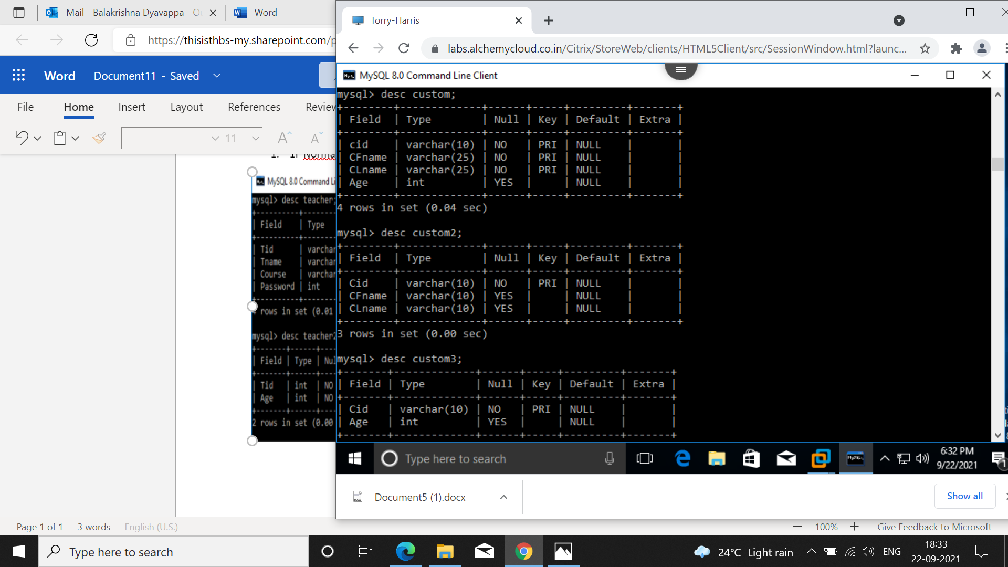

1. 2NF (Second Normal Form)

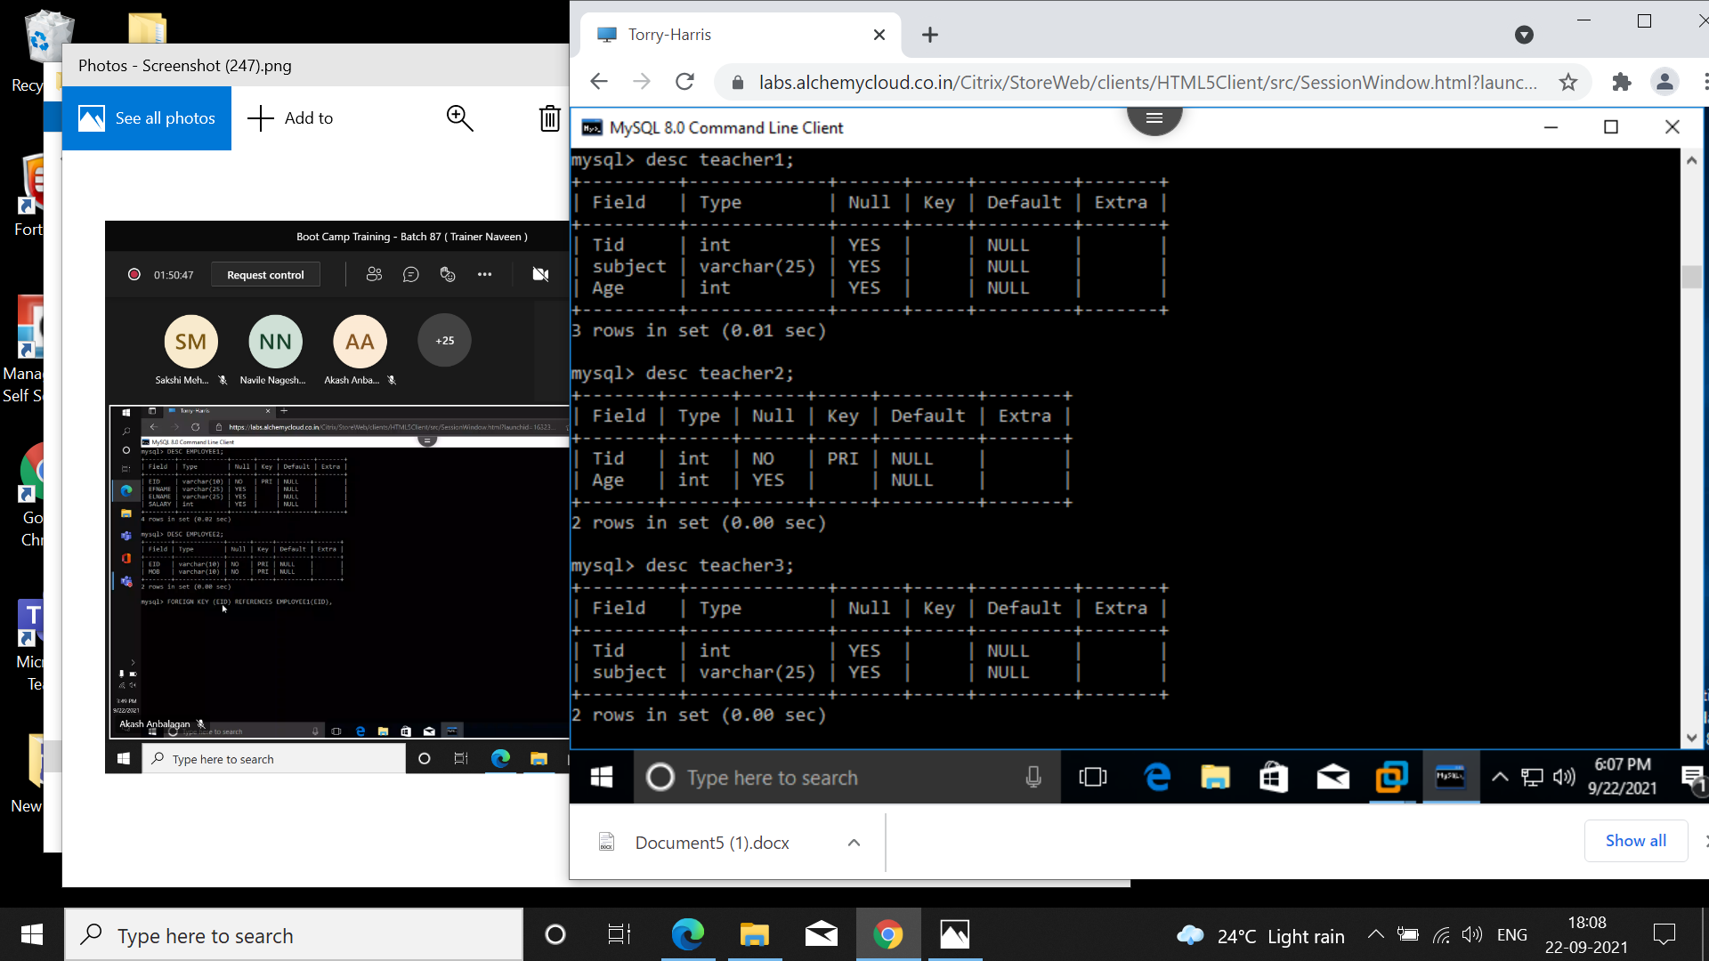

1. 3NF(Third Normal Form)

